This document will document my task “Replace upload input field with url field”.

I went into the CreateFoodPost blazor page and changed the input field with a url field:

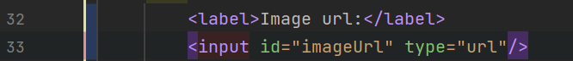

I also added some validation in the Logic layer (Application package):

The method “Uri.IsWillFormedUriString” is something I found online.

This task is not tested as of the 28th of November (Monday).